

SAVITRIBAI PHULE PUNE UNIVERSITY

PROJECT REPORT ON

**“ONLINE PROPERTY MANAGEMENT SYSTEM”**

SUBMMITTED TO



BSPML’s

**JAIKRANTI COLLAGE OF COMPUTER SCIENCE AND MANAGEMENT STUDIES, KATRAJ, PUNE**

AFFILIATED TO

**SAVITRIBAI PHULE PUNE UNIVERSITY**

B.SC COMPUTER SCIENCE

UNDER THE GUIDANCE OF

**PROF. AMOL KALE**

FOR ACADMIC YEAR 2019-2020

SUBMITTED BY

**Mr. NITIN ARUN YEWALE**

**ONLINE PROPERTY MANAGEMENT SYSTEM**

**A PROJECT REPORT**

**Submitted by : Roll No**

1. **Yewale Nitin Arun. 05.**

**In partial fulfillment**

**of**

**Third Year Bachelor Of Science**

**IN**

**COMPUTER SCIENCE**

**Jai Kranti College Katraj**

**Pune .**

**University Of Pune**

**Acknowledgement**

I would like take this opportunity to express thanks to all teachers of Computer Science Department for their continuous support and guidance through the development stages of this project .

I would like to express our heartfelt thanks to all those who where directly or indirectly involve in making this project entitled **“ONLINE PROPERTY MANEGMENT SYSTEM”** Firstly I would like to thanks to my guides-

Prof. Amol Kale Sir.

For their valuable guidance and encouragement, I would also like to express gratitude to all my colleagues and friends for their encouragement, without them the timely completion of the project would not possible.

**INDEX**

**Page No**

1. Introduction
2. Introduction to the System. 5

1. System Study

2.1 Existing System Description 6

2.2 Need of Proposed System 7

2.3 Proposed System Description. 8

2.4 Scope of System 9

2.5 Fact Finding Techniques 10

3. Proposed System

3.1 Feasibility Study 11

a. Operational Feasibility

b. Technical Feasibility

c. Economical Feasibility

* 1. User requirements 12

4. System analysis.



Entity relationship diagram. 13

Data Flow Diagram 15

* 1. 21 Class Diagram

Use-Case Diagram 23

Sequence Diagram 25

Statechart Diagram 27

Activity Diagram 29

Deployment Diagram 31

* 2. + 1. 5. File design
  3. + - 1. Data Dictionary. 33

6. Implementation 37

5.1 Input/output Screens

5.2 Reports .

6. User Manual 56

7. Future Enhancement. 57

8. Bibliography. 58

# 2.SYSTEM STUDY

# 2.1Introduction to System

Property management system is an Estate Agent and Property Management System is a user friendly contact and property manager for real estate professionals. Save time and sell more by empowering to easily keep track of leads, manage listings, and market to new prospects.

One of the most important steps in running a successful real estate business is effectively managing contacts and farming leads. In built scheduler and alarm system will help you to remind your appointment and call back.

**2.1) EXISTING SYSTEM:**

* The customer goes over the Agency & finds for the particular property that he is willing to buy.

* If customer required some property then he may visit the Agency personally or may visit the agent.
* When Customer bought some property then pays the documents and

billed amount at agency or agent.

* The Agency person or agent gives agreement to customer, and keep the copy of the same in a file for reference.
* When a agent has to buy a property that is currently not available at the agency then respected person may register for the particular name of the property in advance, the counterperson registers the request in a rough register and when that property is purchased by customer, the counterperson calls (via phone) the respected persons those have registered for the property.
* The Admin gives purchase order to agent by telephone, when their property is available & also places the order for new properties etc.
* All data has stored in Microsoft Office Excel 2002.
* The Admin person checks daily for property information ,status & also look or search out for new customer , property etc.
* All data regarding the customer details etc are kept in many different registers.

**2.2 NEED OF PROPOSED SYSTEM**

* Right information at right time is required to improve the probability of organization. As the data is maintained in the old fashion ledger, register, account, property, files time taken to search the required information is very difficult to get it quickly and also it is time consuming. If right decision is not taken at the right time it might cause the adverse effect for the company.
* To store the data in the paper, bun+dles of papers are required, and should safely place this type of things as for to end of every transaction it is very much tedious job for to maintain it or it might be get damage or may lost or may get corrupted as the papers are most delicate things.
* Also the calculations made in the manual system are very much time consuming and there is more probability of human error to get introduce in the system. The accuracy is also important in the system that will be useful for the nest calculations. Accuracy in the manual system has errors that cause the inconsistency.
* The property requirement can be recorded and expedited urgently to increase property sales.
* Management can get various reports related to service.

* It is also a difficult job to process report and keeps these records for long time.
* A lot of paper work and documentation is reduced.
* A lot of portion of overheads goes into the unproductive burn of Existing system.
* Existing system is made online, due to which different procedures of company as customer order , maintenance, security, & safety of data, etc are made easier, faster and efficient.

**2.3) Proposed System Description**

1. Provie security to the system at different level
2. Provide right information to the management as and when they required within minimum time.
3. Should get operated independently.
4. To avoid mistakes/difficulties in existing system.
5. To make the system user friendly to buy the property
6. To make the system more secure from hijacker.
7. Available fast information to the customer .
8. The system is also helpful for business application.

**2.4) SCOPE OF SYSTEM**

The Home page will be provided for service module.

* The system will have three users Administrator, Customer and Agent There will separate activities for each user.
* User registration
* User authentication
* Order details
* Property details
* Customer requirement details

* Customer Feedback details
* Property status
* Property Update
* Search Property
* Reports Generation

**2.5) FACT FINDING TECHNIQUES**

After obtaining background knowledge, the information on the existing system’s outputs, inputs and costs were collected. The tools used in data collection were as follows: -

1. **Interview**: - I have used this technique to collect information from individuals and groups. The respondents are essential part of current manual system. Time is the main factor when I was gathering data. Because of the time required for interviewing, other methods were also used together the information needed to conduct as investigation.

This method for fact finding was especially helpful for gathering information from individuals. Interviews allowed me to discover areas of misunderstanding unrealistic explicit expectation, and even indications of resistance to the proposed system. I considered not only the information that was acquired during an interview, but also its significance.

1. **Review of records: -**Many kinds of records and reports were provided with valuable information about organization and its operations. In review of records I examined information that has been recorded about the system and users. I performed record inspection at the beginning of the study. Record includes many types of registers and other documents. The information given by members helped me to understand the relations within the procedures in the organization.
2. **Observations: -** observations allowed me to gain information, which could not be obtained by any other fact-finding methods. Through observation I could obtain fresh information about how the activities were carried out. This helped me when I handled, how were they processed and whether specified steps were followed or not.

So I had mainly used these techniques for collecting the information. Fact-finding offered me an opportunity to go behind the scenes in an organization, to learn inside story, to discover how things actually work in a new area of information.

One thing I must admit that the interviews were unstructured and importance was given to the working members rather than top executives. This helped me to find out the actual nature of their job, what problems they have to face. What were the methods they used while doing their jobs? Top executives are mainly interested in reports.

**3. PROPOSED SYSTEM**

**3.1FEASIBILITY STUDY**

Feasibility Study is preliminary investigation, which emphasizes the ‘LOOK BEFORE YOY LEAP’ approach to any important project. The feasibility study is under taken to determining a completely new system. Positive result from feasibility studies from one the key influence in the development of project, as they decide whether to go on with work further or not. Thus it forms a vital part of the preliminary phase of system development of life cycle. This is essential to avoid committing large resources to a project and then repeat on it later.

Feasibility study was carried out considering the following factors :-

1. **Technical feasibility:**

**“**It is most function performance and constraints that may affect the ability to achieve accepted system**”**

Technical feasibility it frequently the most default to access at this stage of the system development process. Because objectives, function and performance are some what easy, anything seems possible if the right assumptions are made. It is that the process analysis and definition be conducted in parallel with an assessment of technical feasibility.

The considerations that are normally associated with technical feasibility include:

* Development risk.
* Resource availability.
* Technology.

The Hardware requirements are available.

HARDWARE

4GB , RAM = 256 MB

HARD DISK = 40 GB

SOFTWARE

PSQL , JSP

**2.Economical feasibility study :**

“It is an evaluation of development cost weighted against the ultimate income or benefit derived income from the development system”.

It is the study of actual cost and benefits of the system. This is to information the management about the cost of required to develop system. This system offers various applications that will save large amount of manual work and their valuable time. The proposed system will simplify the day-to-day activities. The system is much simpler to handle.

1. **Operational feasibility :**

The proposed system is extremely user friendly to work with. The system will be beneficial for organization as delay time is reduces and the manpower requirements are utilized for other work.

**3.2 USER REQUIREMENTS**

1] The business goal for the application is to increase efficiency of registration process.

2] It provides powerful serach facilities and capable of matching the property with customer.

3] All the users of the property management system should get all information within the time.

4] The property management system is user friendly contact and property manager for real estate professionals and customers.

5] It save time and easily keep track of leads, manage listins and market to new prospects.

6] system is complete end to end solution. cover all aspects of estate and agent and customer.

7] If the property is sold permanently we will delete it from display records.

8] we will requied customer name , phone no, address, pan card.

9] This system provides property search category for the customer. In search category we will provides properties like flats, banglo, rowhouse, plot.

10] Then provide citywise location.

**4) SYSTEM ANALYSIS**

**ENTITY RELATIONSHIP DIAGRAM**

Search for

Insert

for

Property

Administrator

Agent

Customer

1 1

update

1 M

M

ISA

ON RENT

ON SALE

Residential

Commercial

Residential

Commercial

ISA

ISA

**4.1 DATA FLOW DIAGRAM**



**PROCESS FOR ACCEPTING INFORMATION:**

**Module 1- Generating Information:**



**Module 2-Add information PROCESS 2.0**



**Module 3- Check validation**



**Module 4-Report Generation**



**4.3 CLASS DIAGRAM:**

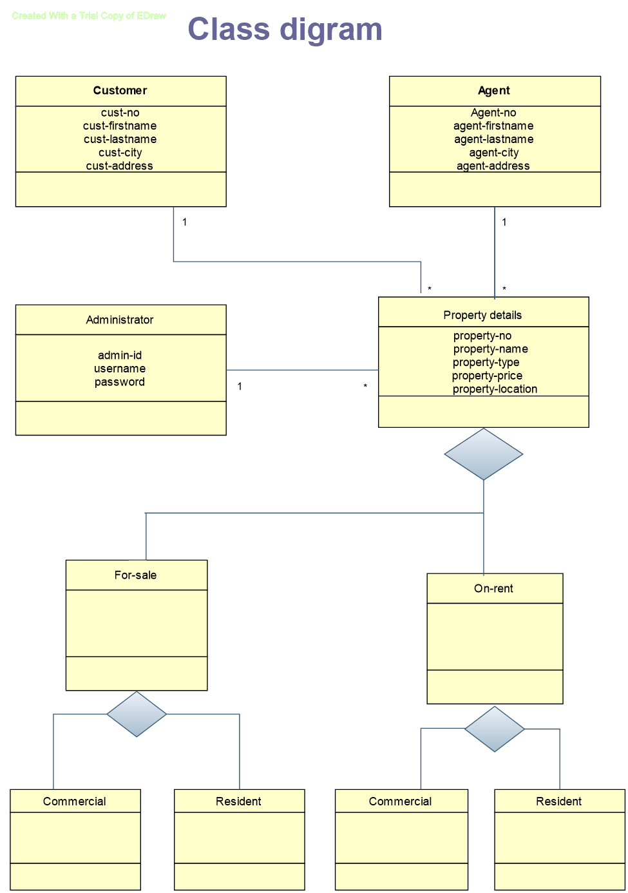

4.4 USE- CASE DIAGRAM:

Customer

Admin

Agent

4.5 SEQUENCE DIAGRAM:

**Customer**

**Agent**

**Administrator**

**Property**

**New user**

**submit**

**old/login**

**fill the form**

**allow access**

**send request**

**view result**

**display no result found**

**confirm order ifany**

**send contact details**

**send logout request**

**logout**

**new agent**

**fill the form**

**old user login**

**submit**

allow access

**insert/update**

**view account**

**display account details**

**send logout request**

**logout**

**search property**

**property details**

**not found**

**update property details**

**4.6 STATE CHART DIAGRAM:**

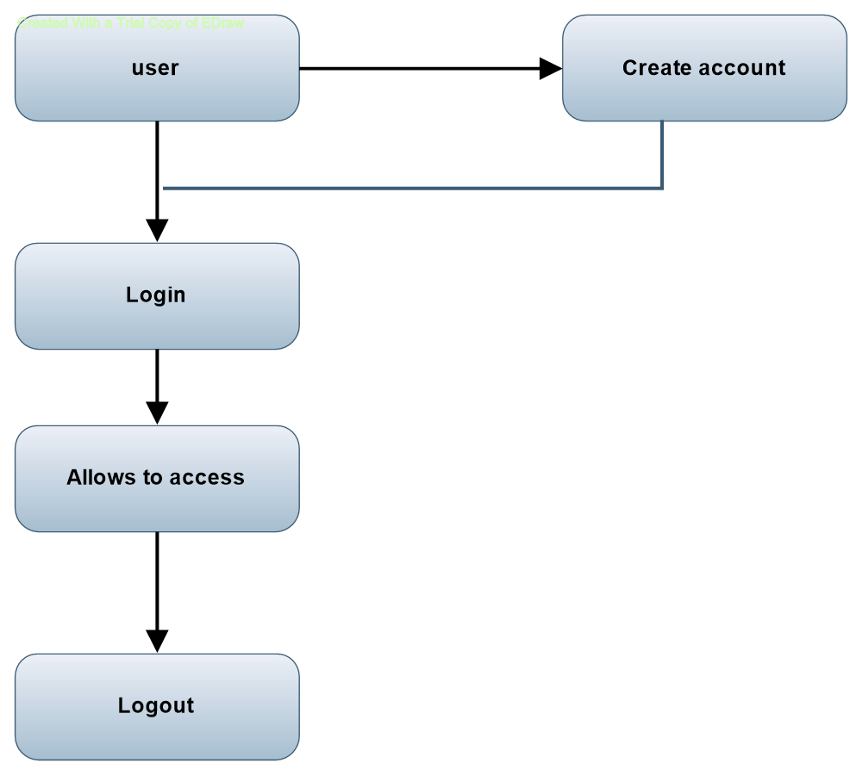

**4.7 ACTIVITY DIAGRAM:**

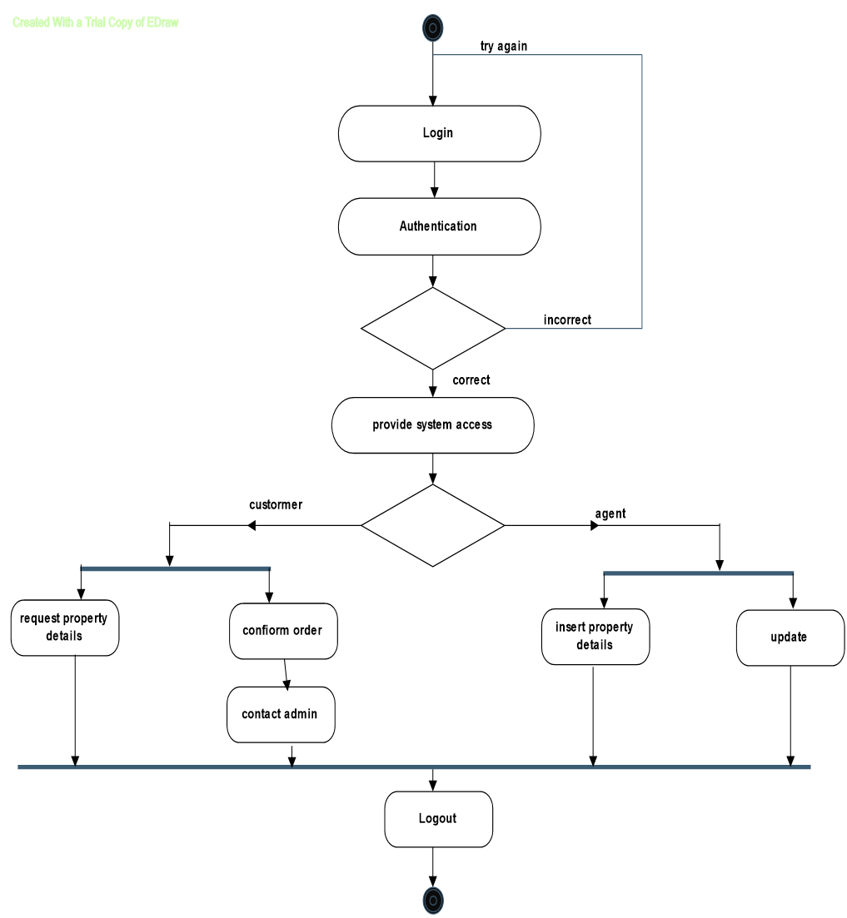

**4.8 DEPLOYMENT DIAGRAM:**



**5.FILE SYSTEM**

**5.1 Data Dictionary**

1]Table name-Customer

Primary Key: cust_id

|  |  |  |  |  |
| --- | --- | --- | --- | --- |
| **Sr.no -** | **Field Name** | **Data Type** | **Width** | ***Constraints*** |
| **1** | cust_id | Varchar | 4 | *Primary Key* |
| **2** | cust_user_name | Varchar | 15 | *Not null* |
| **3** | cust_password | Varchar | 8 | *Not null* |
| **4** | cust_gender | Char | 10 | *Not null* |
| **5** | cust_first_name | Varchar | 10 | *Not null* |
| **6** | cust_last_name | Varchar | 10 | *Not null* |
| **7** | cust_address | Varchar | 20 | *Not null* |
| **8** | cust_zip_code | Int | 8 | *Not null* |
| ***9*** | cust_city | Varchar | 15 | *Not null* |
| ***10*** | cust_state | Varchar | 15 | *Not null* |
| ***11*** | cust_country | *Varchar* | *12* | *Not null* |
| ***12*** | cust_email | *Varchar* | *30* | *Not null* |
| ***13*** | cust_phone | *Varchar* | *12* | *Not null* |
| ***14*** | *cust_regisration_dt* | *Date* |  | *Not null* |
| ***15*** | *is_active* | *Char* | *10* | *Not null* |

2] Table name-Agent

**Primary Key: Agent_id**

|  |  |  |  |  |
| --- | --- | --- | --- | --- |
| **Sr.no** | **Field Name** | **Data Type** | **Width** | ***Constraints*** |
| **1** | Agent_id | Varchar | 4 | *Primary Key* |
| **2** | Agent_user_name | Varchar | 15 | *Not null* |
| **3** | Agent_password | Varchar | 8 | *Not null* |
| **4** | Agent_gender | Enum | 01 | *Not null* |
| **5** | Agent_first_name | Varchar | 10 | *Not null* |
| **6** | Agent_last_name | Varchar | 10 | *Not null* |
| **7** | Agent_address | varchar | 20 | *Not null* |
| **8** | Agent_zip_code | Int | 8 | *Not null* |
| ***9*** | Agent_city | Varchar | 15 | *Not null* |
| ***10*** | Agent_state | Varchar | 15 | *Not null* |
| ***11*** | Agent_country | *Varchar* | *12* | *Not null* |
| ***12*** | Agent _email | *Varchar* | *30* | *Not null* |
| ***13*** | Agent _phone | *Varchar* | *12* | *Not null* |
| ***16*** | Agent*_regisration_dt* | *Date* |  | *Not null* |

3] Table Name - Property

Primary Key - P_id

|  |  |  |  |
| --- | --- | --- | --- |
| Sr.no | Field Name | Data Type | Constraints |
| 1 | P_id | Int | Primary Key |
| 2 | P_name | Varchar | Not Null |
| 3 | P_type | Int | Not Null |
| 4 | P_location | Varchar | Not Null |
| 5 | P_status | Varchar | Not Null |
| 6 | P_area | Varchar | Not Null |

4] Table Name = Administrator

Primary Key = Ad_id

|  |  |  |
| --- | --- | --- |
| Field Name | Data Type | Constraints |
| Ad_id | Int | Primary Key |
| Ad_name | Varchar | Not Null |
| Ad_username | Varchar | Not Null |
| Ad_password | Varchar | Not Null |

5] Table Name = Category

Primary Key = cat_id

|  |  |  |
| --- | --- | --- |
| Field Name | Data Type | Constraints |
| cat_id | Int | Primary Key |
| cat_name | Varchar | Not Null |

**6.Input/Output Screens**

**And**

**Report Layouts**

Home Page:

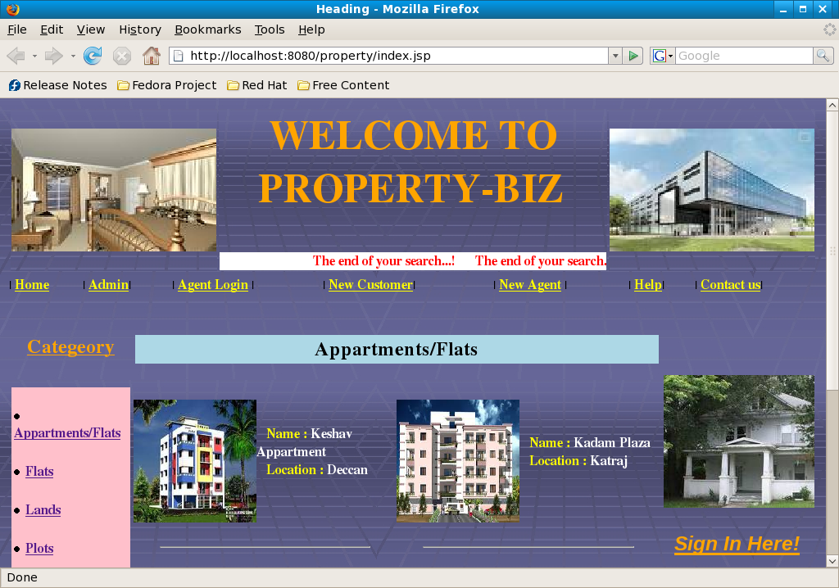

Property Category:

1.Appartment

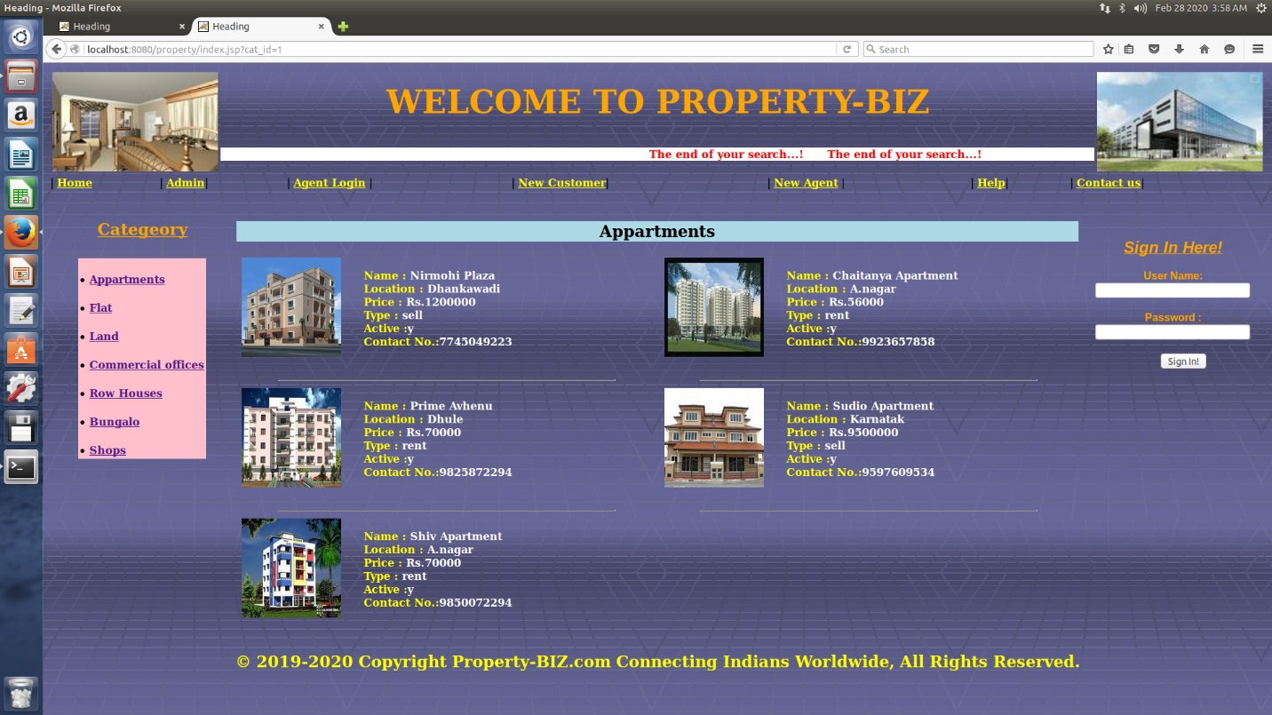

2.Flat

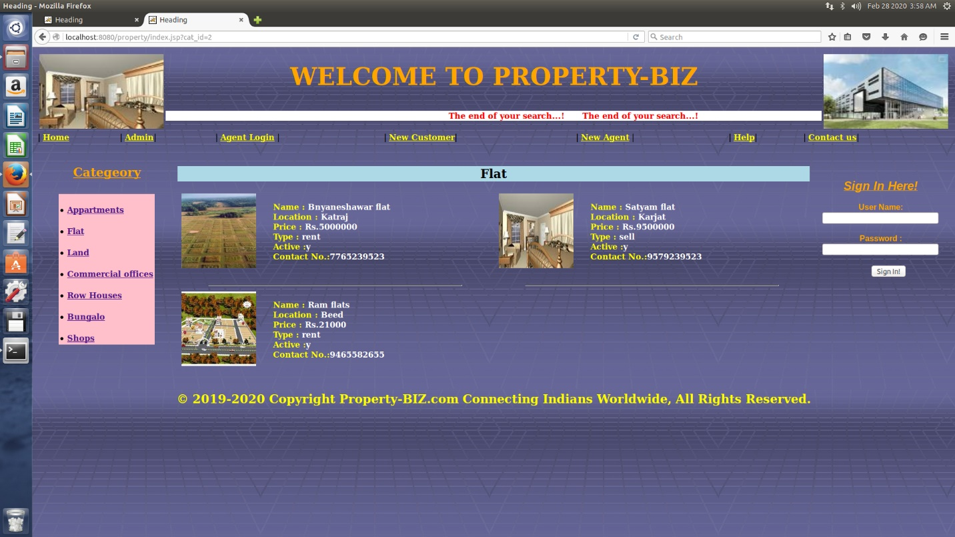

3.Land

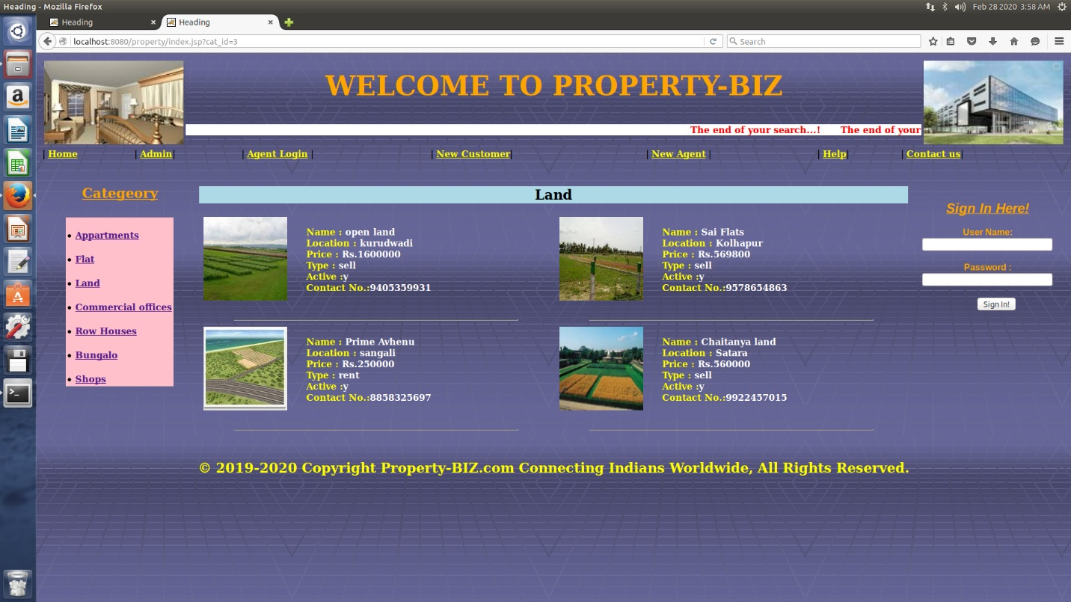

4.Commercial Office

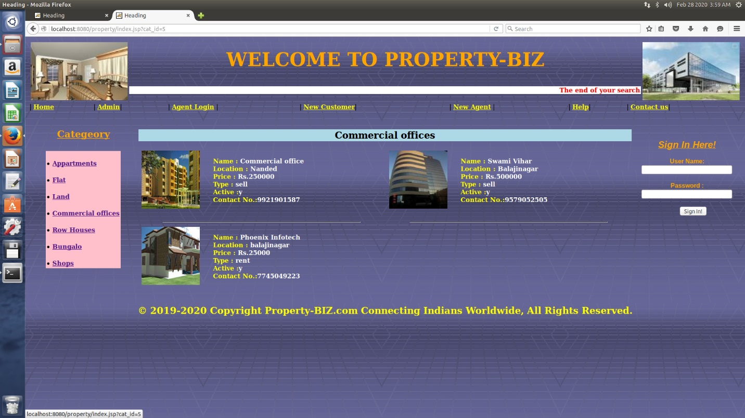

5.Row House

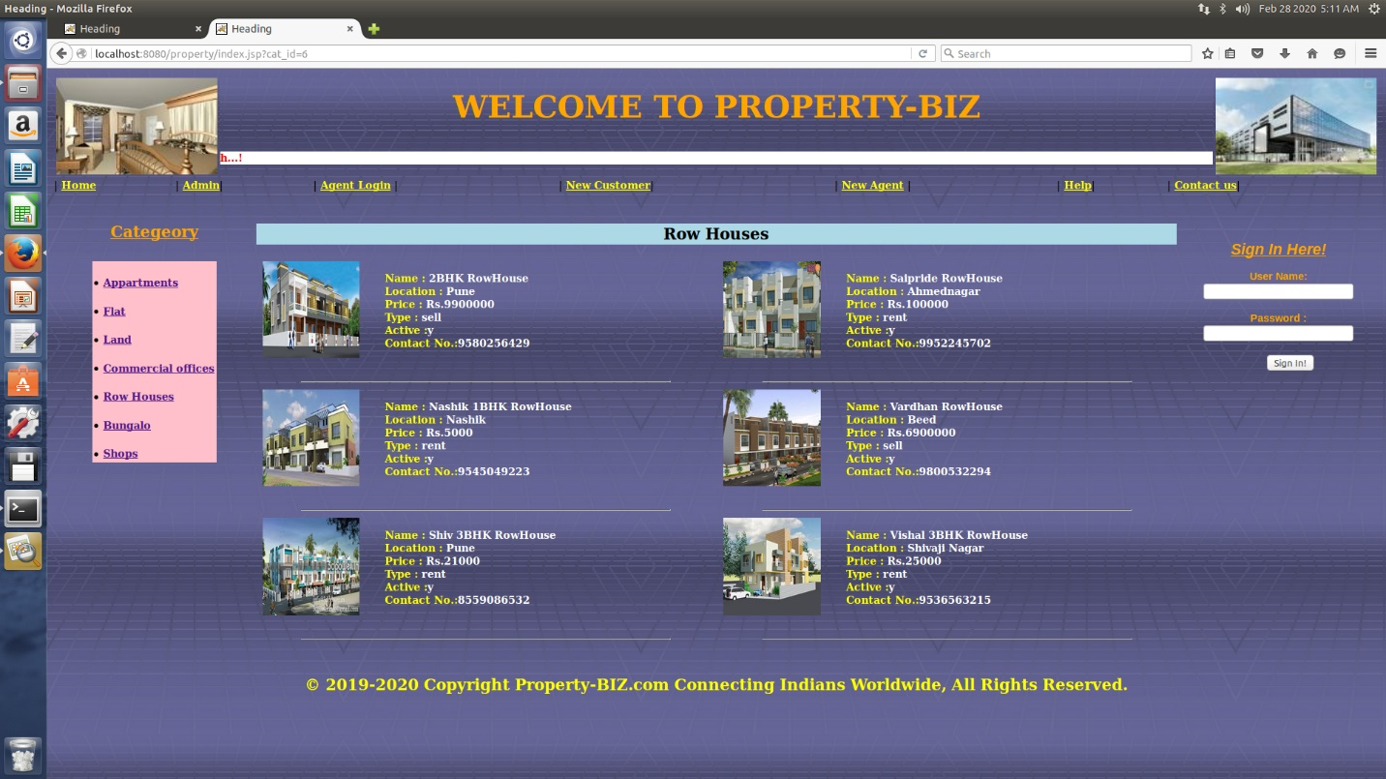

6.Bunglo

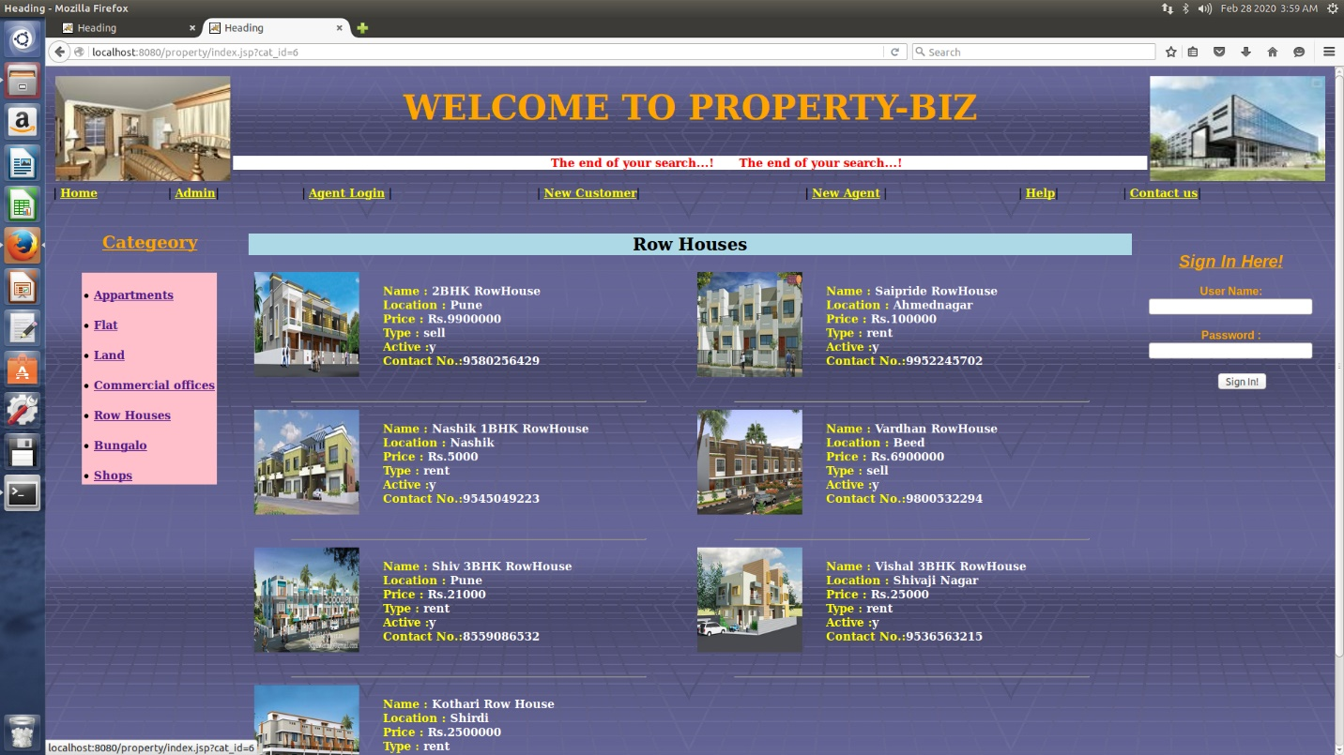

7.Shops

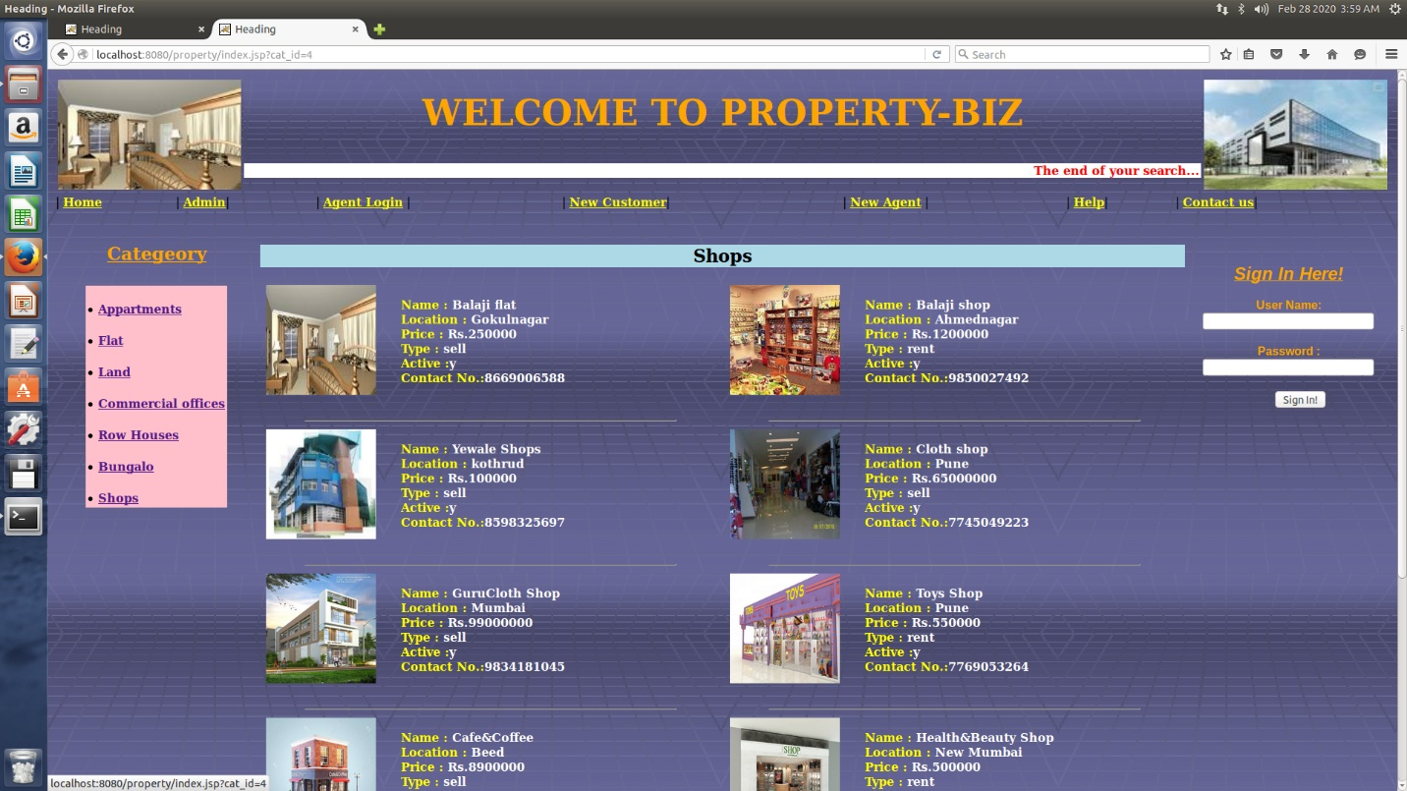

2.Customer Registration:

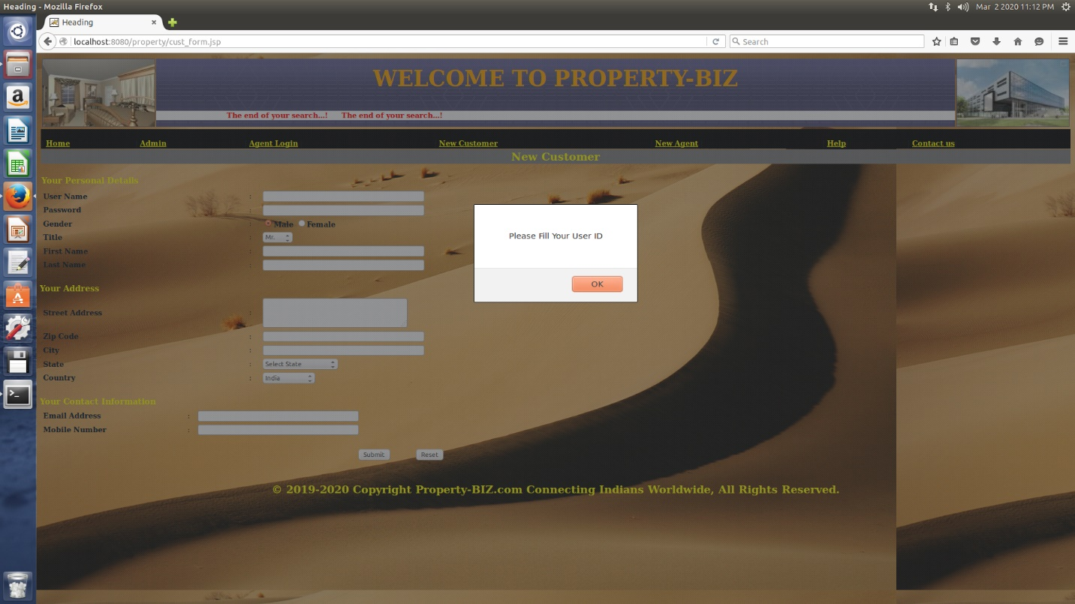

* 1. Select State:

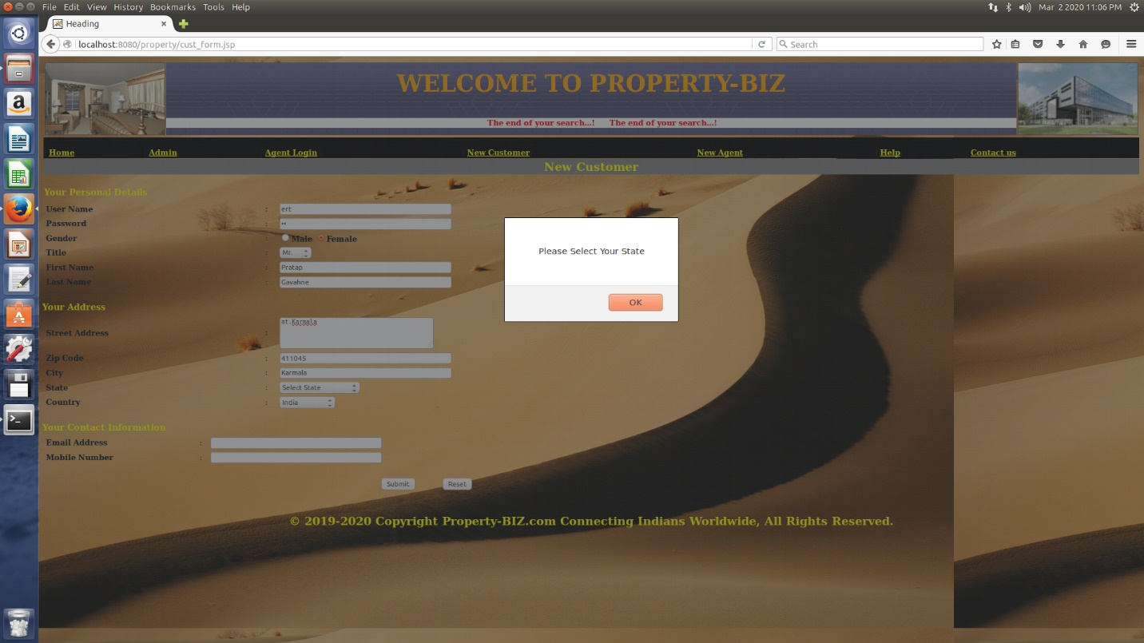

Email id validation:

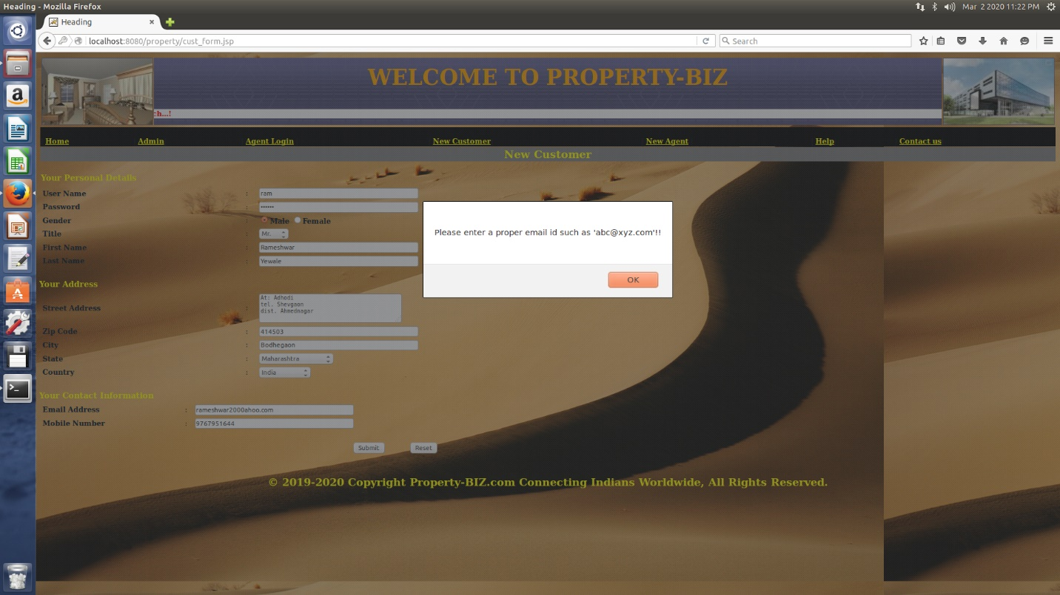

Contact number validation:

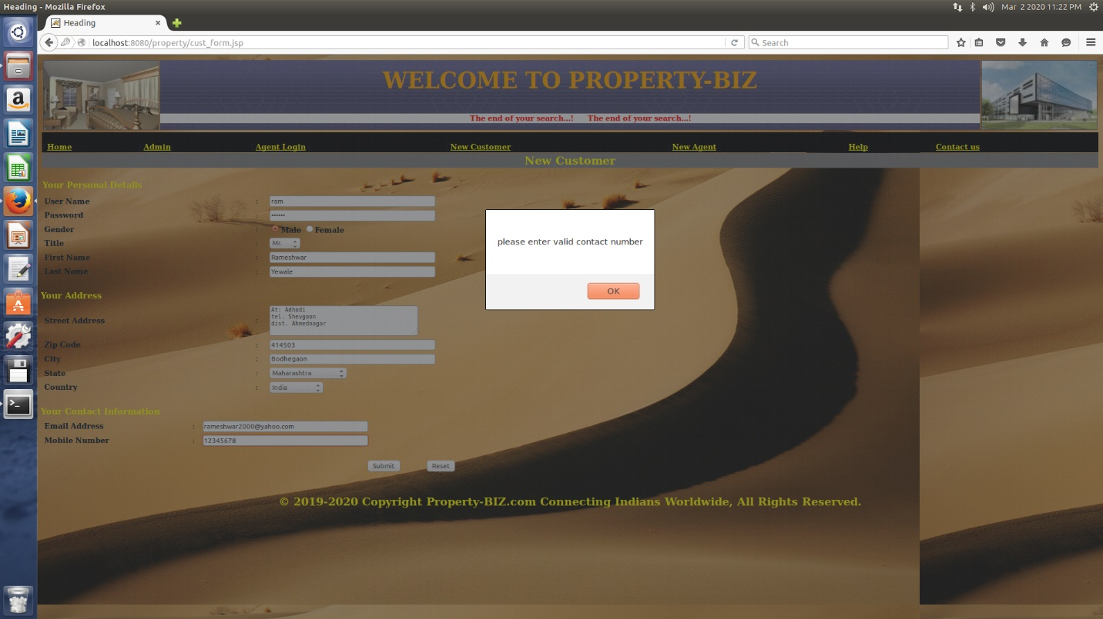

Correct information:

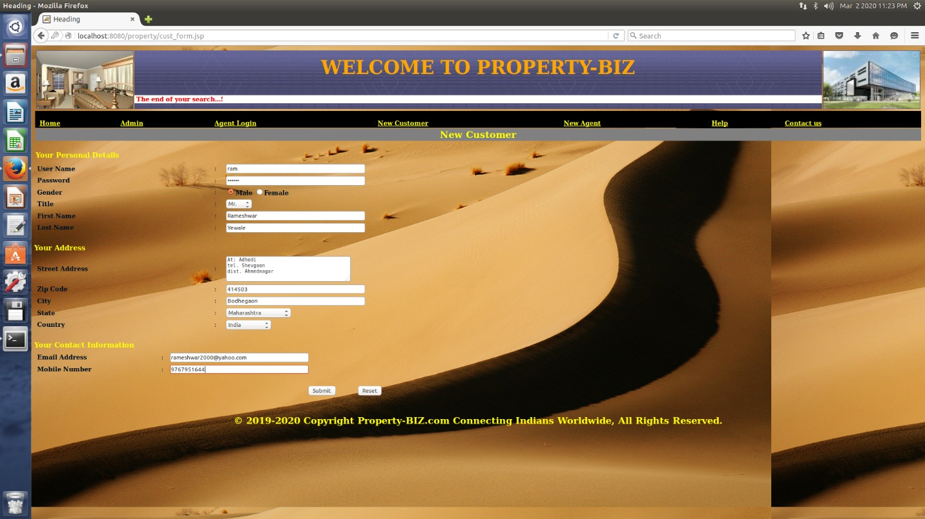

Success full registration

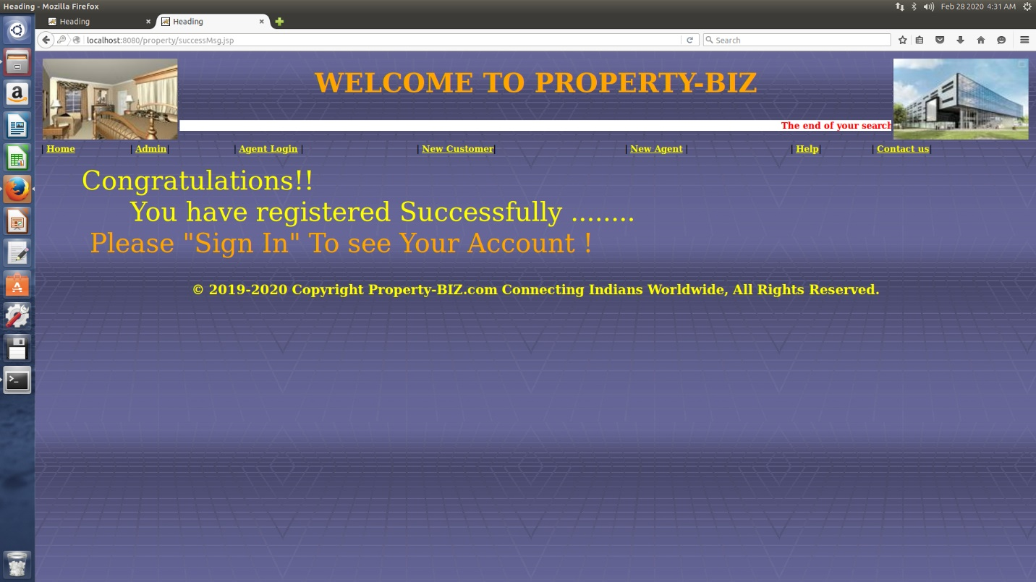

Sign in Existing Customer:

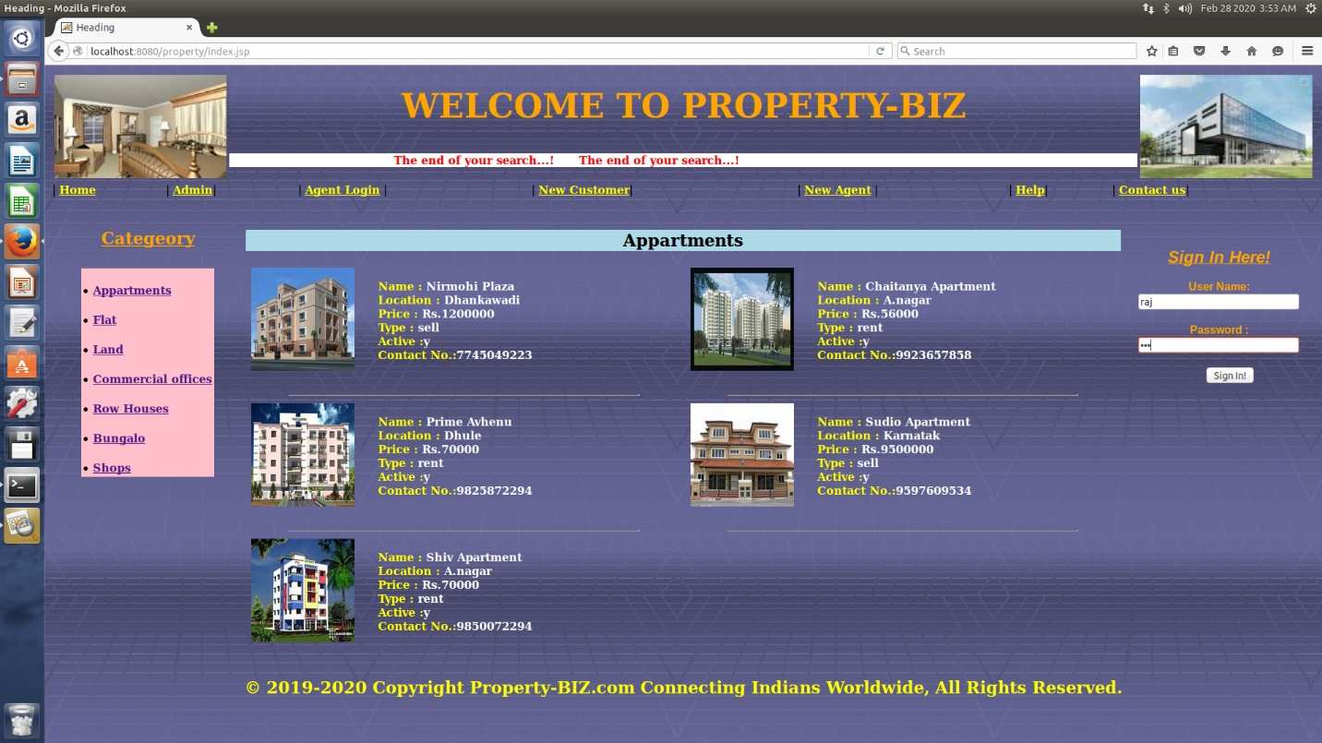

Customer property

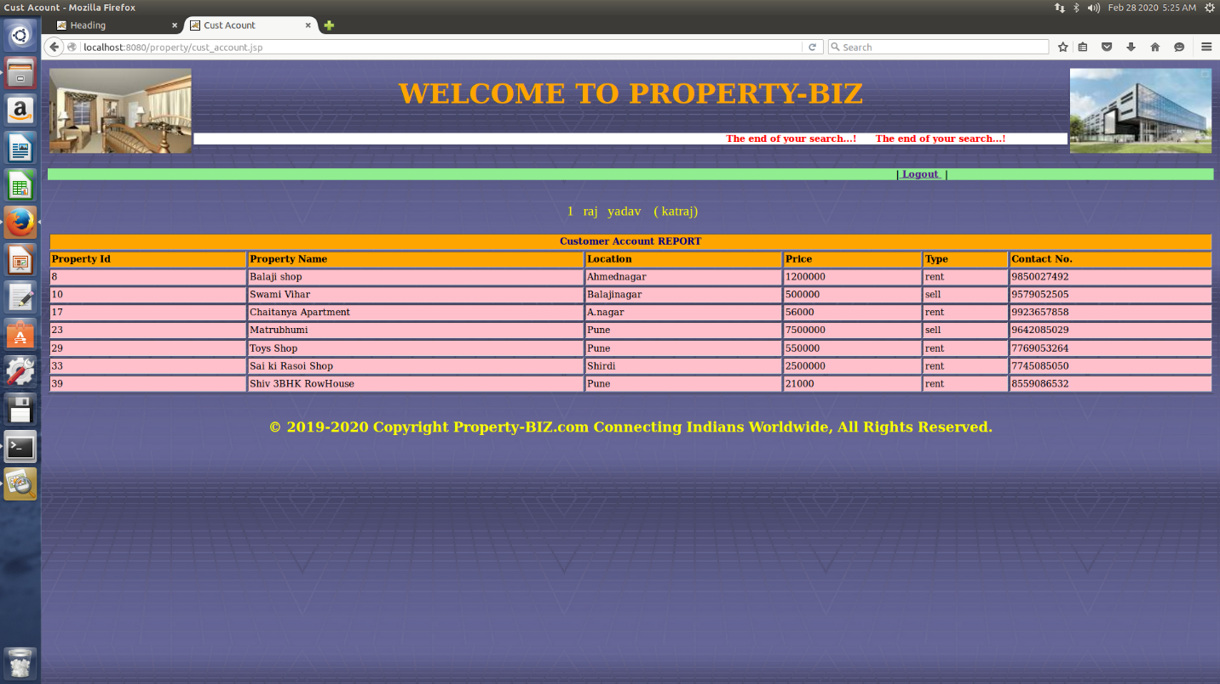

**3.Agent**

Agent registration

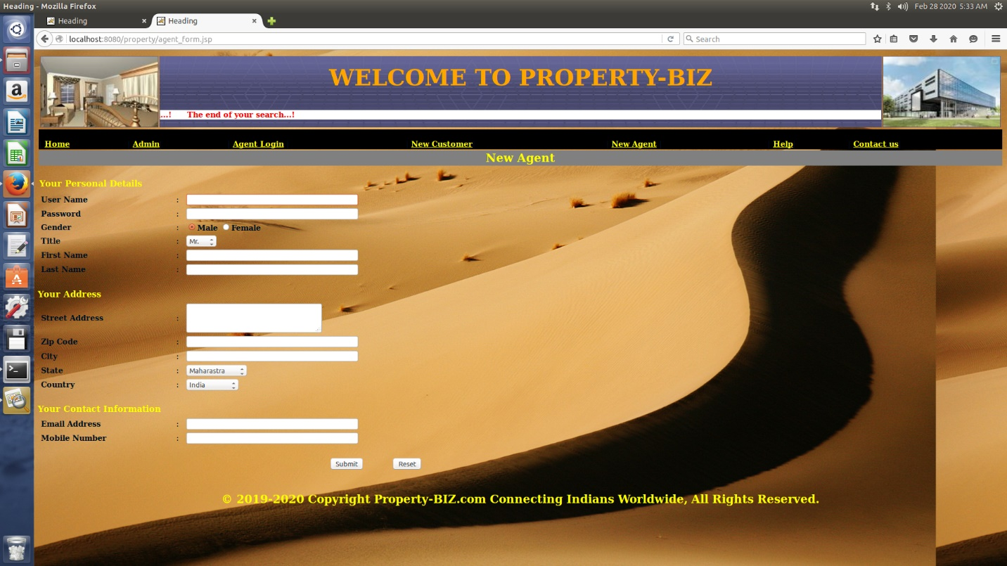

Incorreect Last Name:

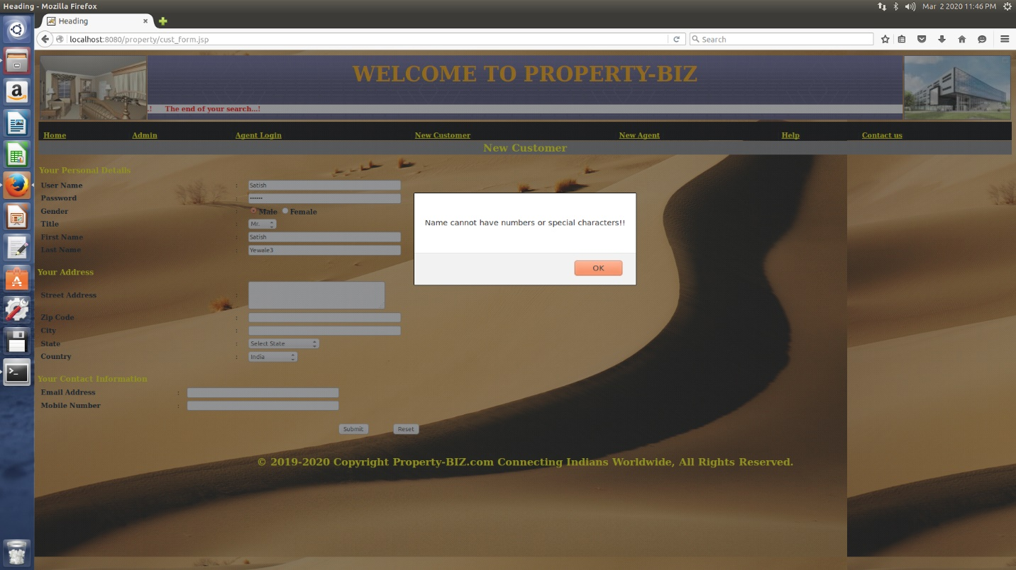

Incorrect Phone No.

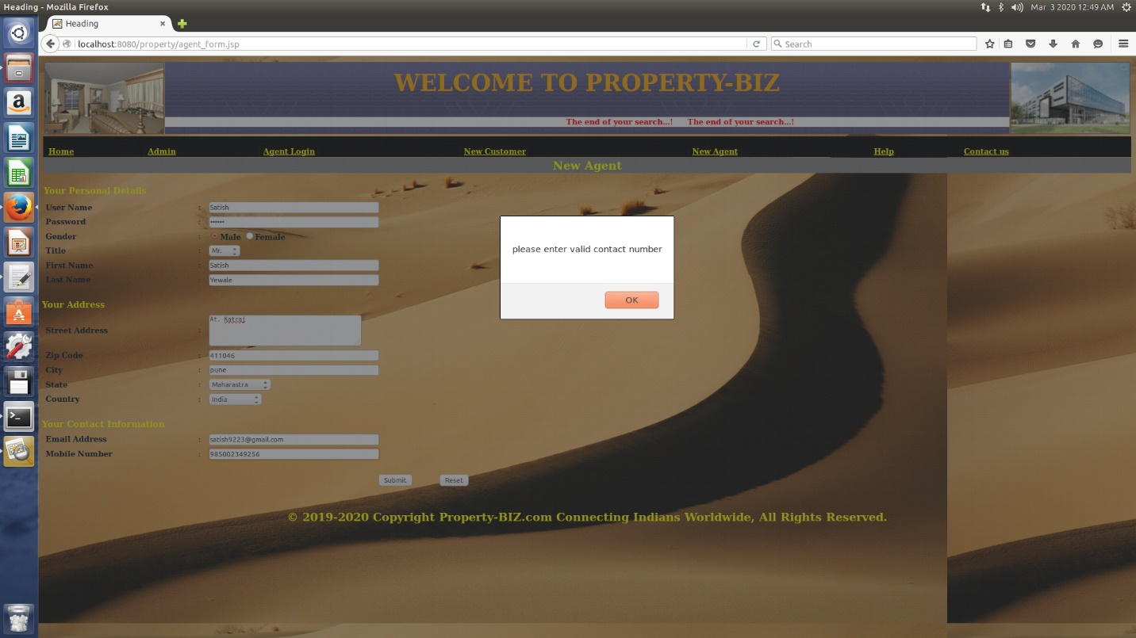

Correct iformation

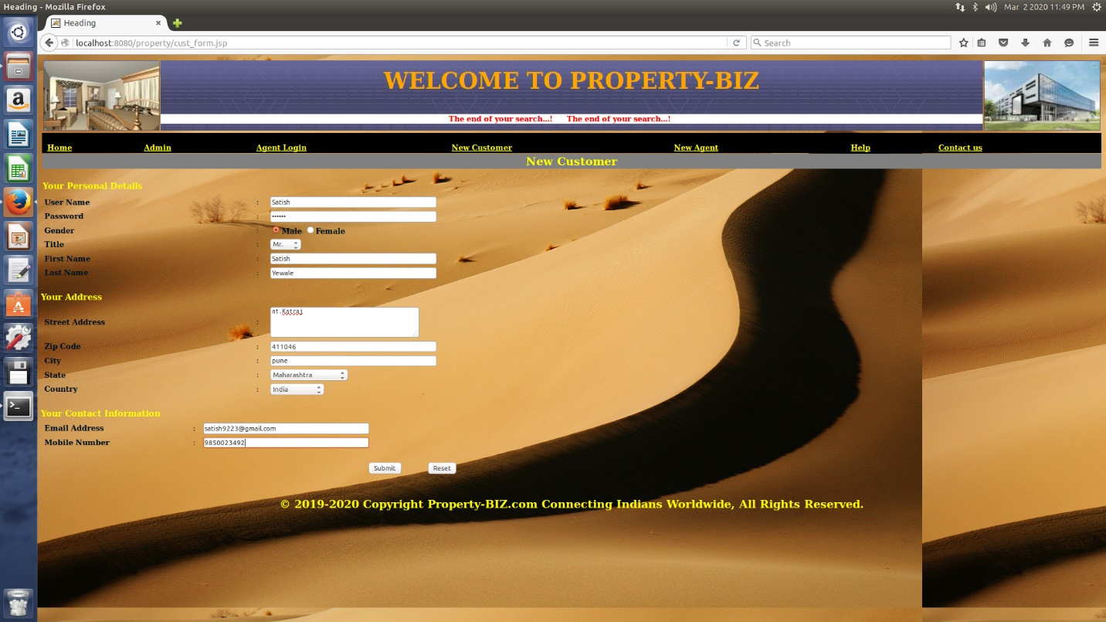

Agent registration Successful



Agent Login

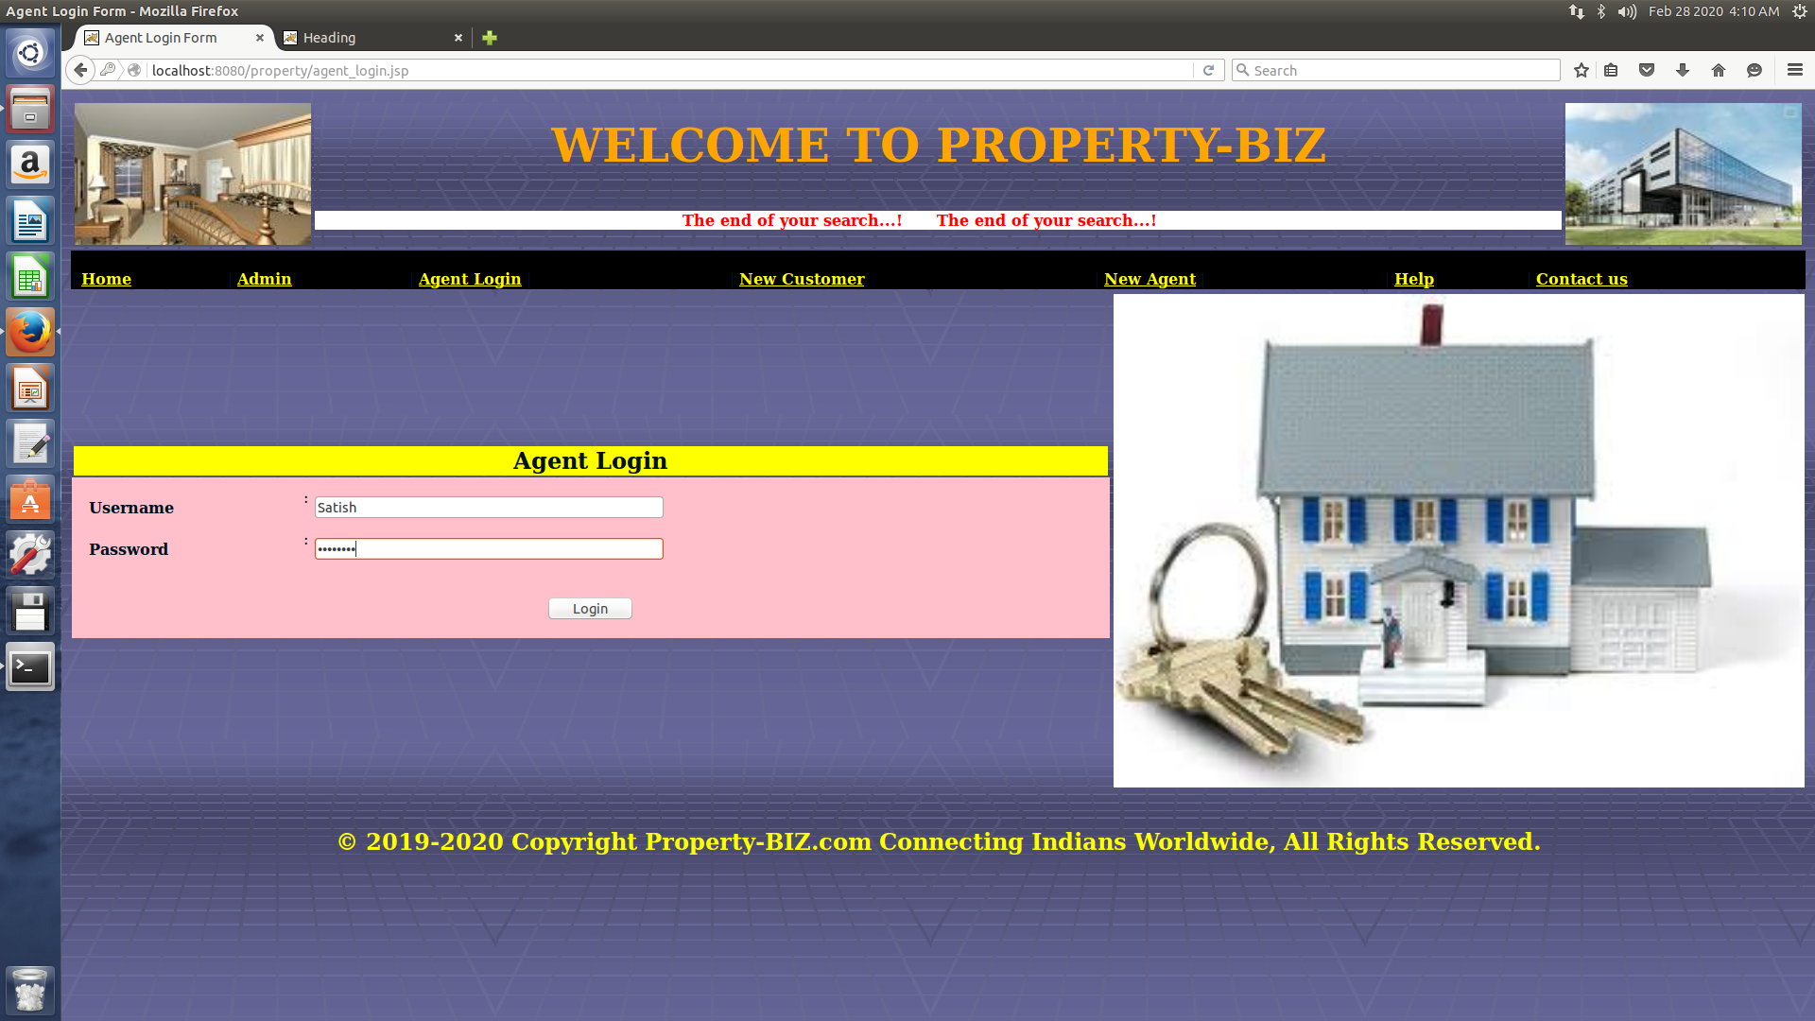

Error Inccorect Agent_login

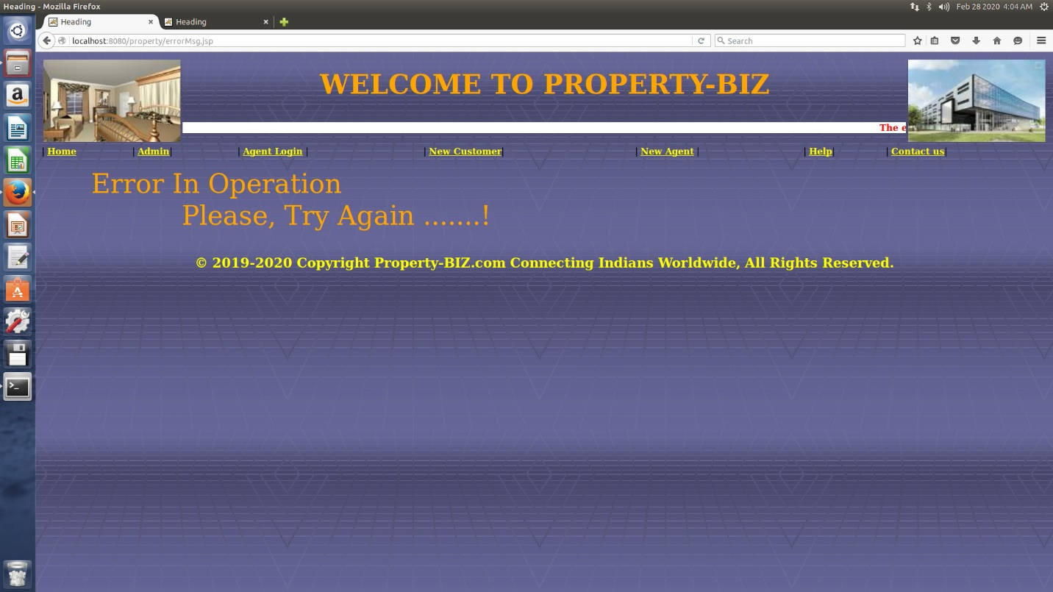

Login Successful



Agent Action add

Add property:

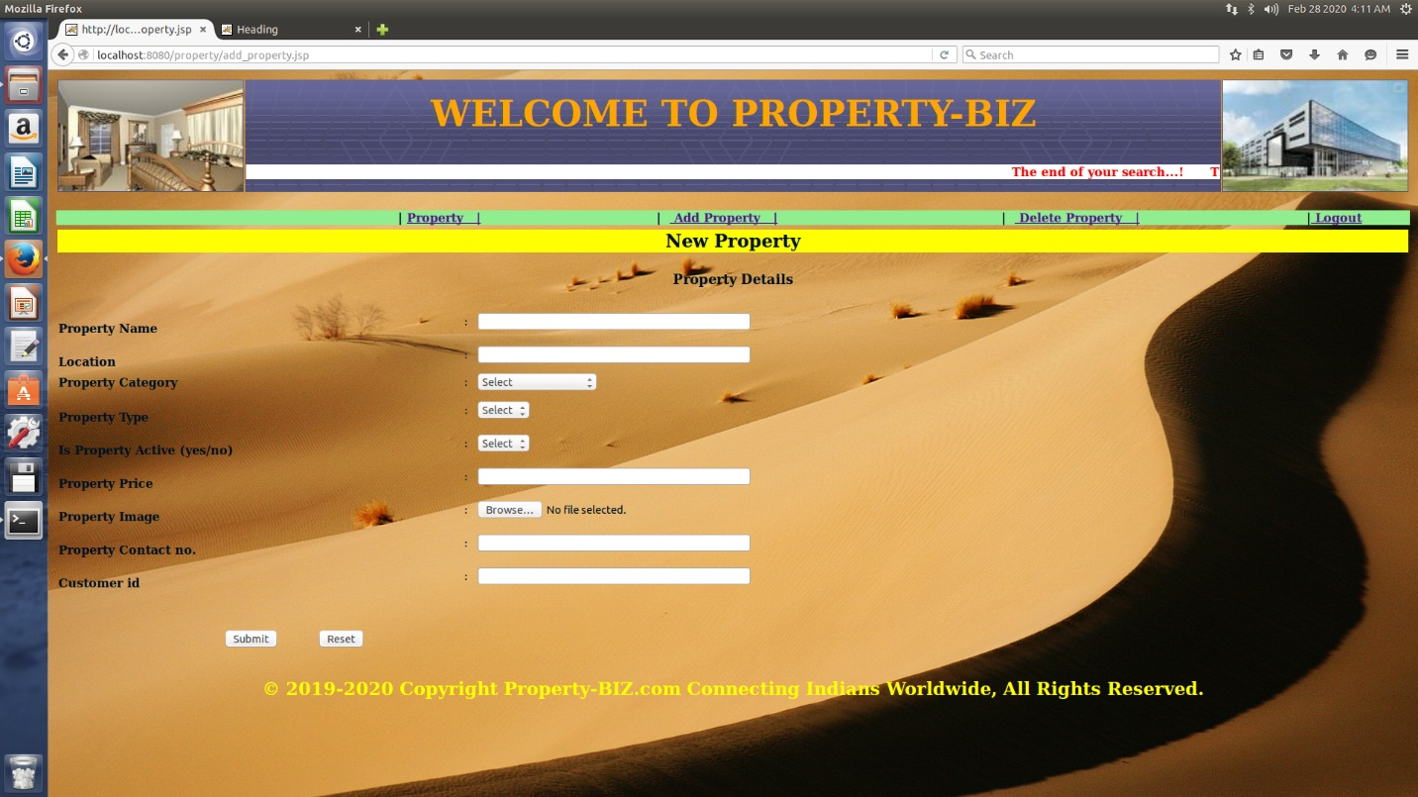

Select image:

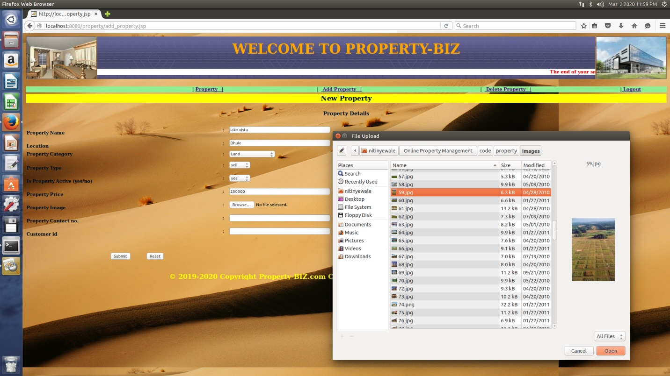

Correct Property detail:

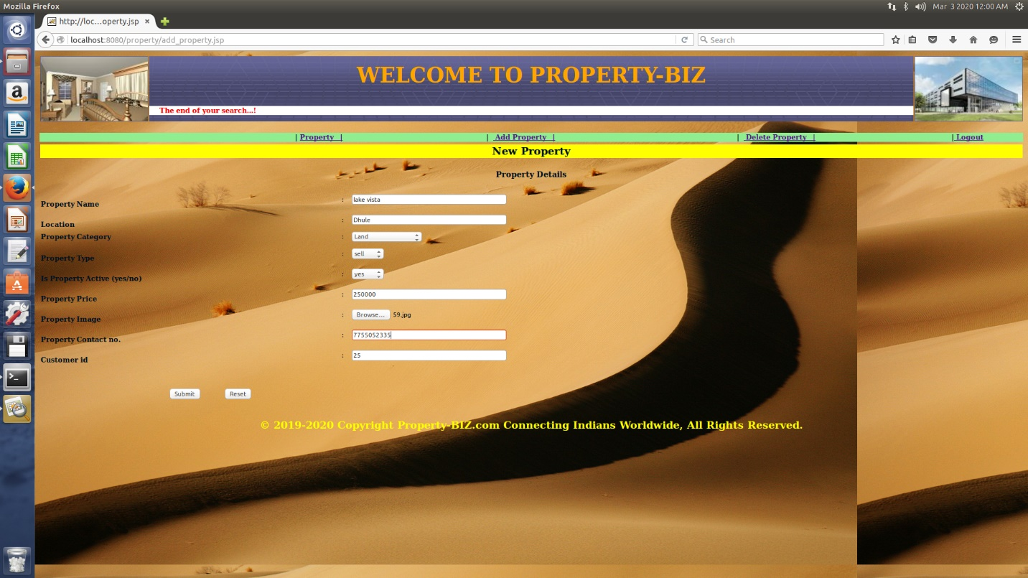

Property added:

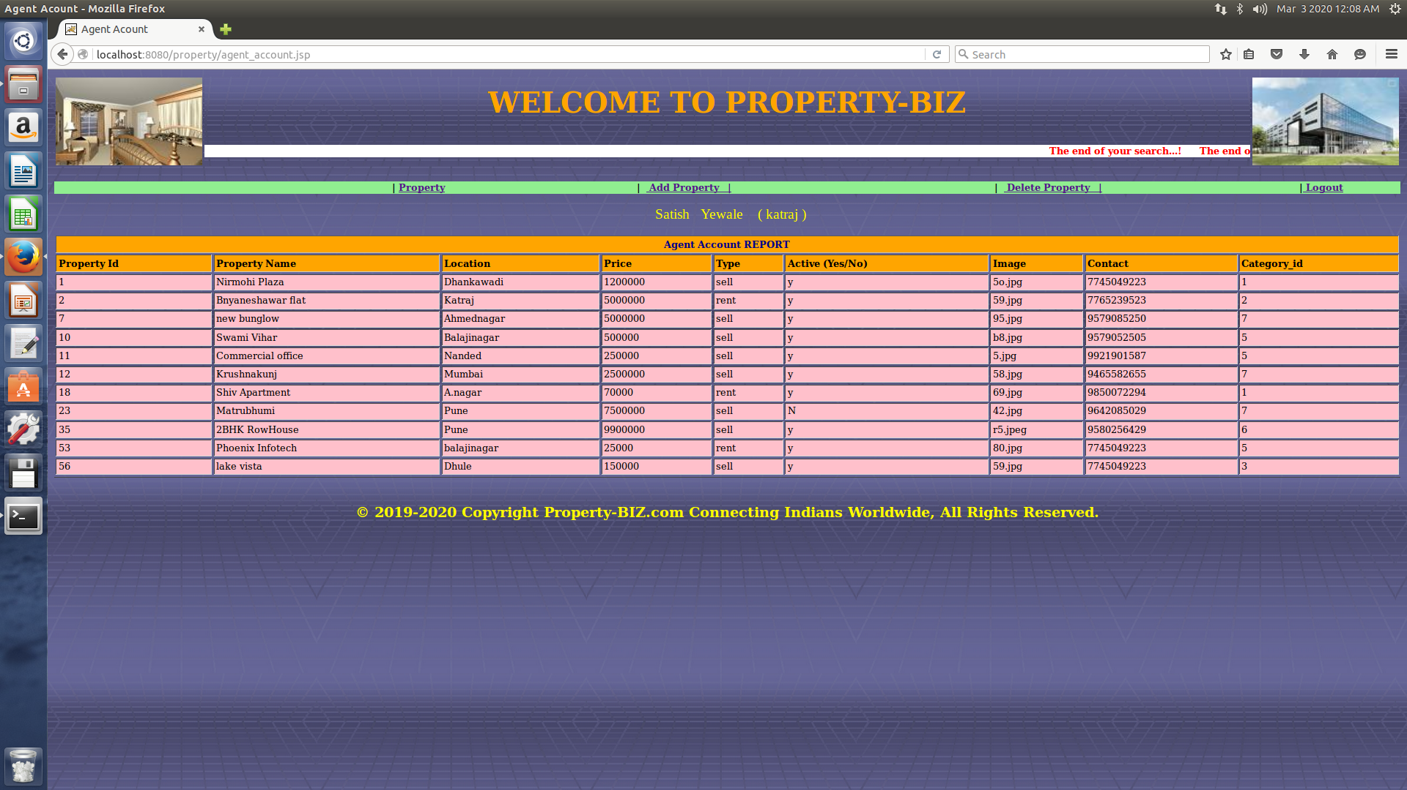

Delete Property

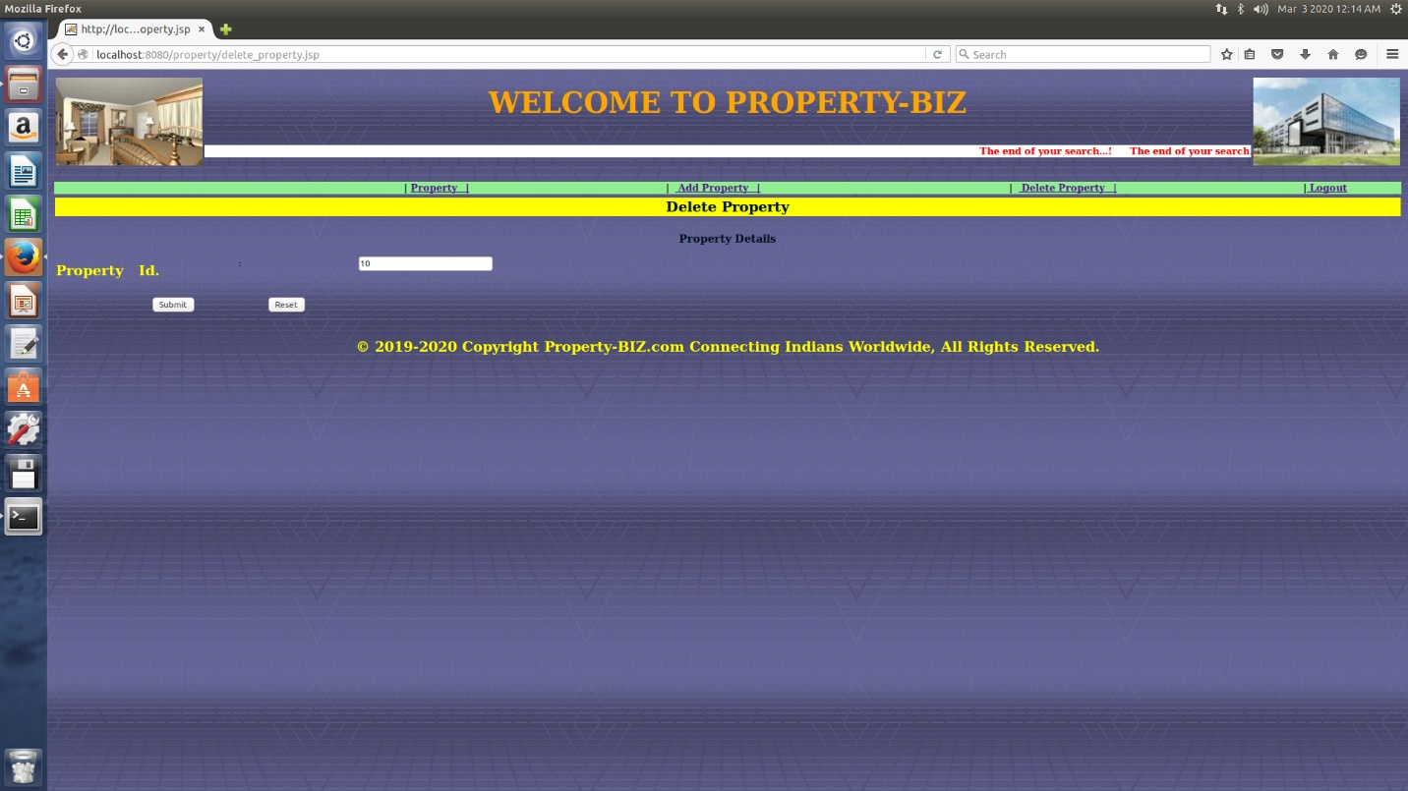

User Manual

User manual is a document provided for the user to see how the computerized system works actually. It describes everything about how the system can be used i.e. how the data is to be entered in the system what input are acceptable and how are they to be entered in to the controls.

Property management system is a computerized system and is completely menu driven. Here the user just has to choose the given options on the forms according to his requirement. The whole project in accordance to the operation is described as under:-

GUI Name:-Home Page

**Purpose: -** To given the user an environment to do transaction with the system

**Description: -** This form contains the links through which the user can navigate through the entire project. All the other form links will be show in this page only. This page contains sub links clicking on it other required from will be displayed. This page contains login information’s like admin and customer. On clicking login button, any type of user can access his page according to type.

FURTURE ENHANCEMENTS

# Even the software developed by great programmers with almost care has there limitations. Our system needs enhancement on

# Mostly sold property should be highlight on site.

Need to develop search engine according to size, location of the property for handling database in a very easy way.

Need to develop ‘Edit’ and ‘Delete’ option for Customer .

Need to host this site on particular server for popularization of this site in customers.

BIBLIOGRAPHY

Websites

Article on ‘company profile’ is expected from company’s official information.

For searching data related to image search Engine used was <http://www.google.com>

<http://www.sulekha.com>